Nunyara Aboriginal Health Service Privacy Information
Current as of: May 2023
Introduction
This privacy document is to provide information to you, our patient, on how your personal information (which includes your health information) is collected and used within our practice, and the circumstances in which we may share it with third parties.
Why and when your consent is necessary
When you register as a patient of our practice, you provide consent for our GPs and practice staff to access and use your personal information so they can provide you with the best possible healthcare. Only staff who need to see your personal information will have access to it. If we need to use your information for anything else, we will seek additional consent from you to do this.
Why do we collect, use, hold and share your personal information?
Our practice will need to collect your personal information to provide healthcare services to you. Our main purpose for collecting, using, holding and sharing your personal information is to manage your health. We also use it for directly related business activities, such as financial claims and payments, practice audits and accreditation, and business processes (eg staff training).
What personal information do we collect?
The information we will collect about you includes your:
- names, date of birth, addresses, contact details
- medical information including medical history, medications, allergies, adverse events, immunisations, social history, family history and risk factors
- Medicare number (where available) for identification and claiming purposes
- healthcare identifiers
- health fund details.
Dealing with us anonymously
You have the right to deal with us anonymously or under a pseudonym. However, if you do so, we may not be able to provide you with accurate or useful information, and you may not be able to access a full range of our operations and services.
How do we collect your personal information?
Our practice may collect your personal information in several different ways.
- When you make your first appointment our practice staff will collect your personal and demographic information via your registration.
- During the course of providing medical services, we may collect further personal information. Information can also be collected through electronic transfer of prescriptions (eTP) and My Health Record (eg. Via Shared Health Summaries)
- We may also collect your personal information when you visit our website, send us an email or SMS, or telephone us.
- In some circumstances personal information may also be collected from other sources. Often this is because it is not practical or reasonable to collect it from you directly. This may include information from:
- your guardian or responsible person
- other involved healthcare providers, such as specialists, allied health professionals, hospitals, community health services and pathology and diagnostic imaging services
- your health fund, Medicare, or the Department of Veterans’ Affairs (as necessary).
When, why and with whom do we share your personal information?
We sometimes share your personal information:
- with third parties who work with our practice for business purposes, such as accreditation agencies or information technology providers – these third parties are required to comply with APPs and this policy
- with other healthcare providers
- To government departments for notifiable disease purposes
- when it is required or authorised by law (eg court subpoenas)
- when it is necessary to lessen or prevent a serious threat to a patient’s life, health or safety or public health or safety, or it is impractical to obtain the patient’s consent
- to assist in locating a missing person
- to establish, exercise or defend an equitable claim
- for the purpose of confidential dispute resolution process
- when there is a statutory requirement to share certain personal information (eg some diseases require mandatory notification)
- during the course of providing medical services, through eTP, My Health Record (eg via Shared Health Summary, Event Summary).
Only people who need to access your information will be able to do so. Other than in the course of providing medical services or as otherwise described in this policy, our practice will not share personal information with any third party without your consent.
We will not share your personal information with anyone outside Australia (unless under exceptional circumstances that are permitted by law) without your consent.
Our practice will not use your personal information for marketing any of our goods or services directly to you without your express consent. If you do consent, you may opt out of direct marketing at any time by notifying our practice in writing.
Our practice may use your personal information to improve the quality of the services we offer to our patients through research and analysis of our patient data.
We may provide de-identified data to other organisations to improve population health outcomes. The information is secure, patients cannot be identified and the information is stored within Australia. You can let our reception staff know if you do not want your information included.
How do we store and protect your personal information?
Your personal information may be stored at our practice in various forms, including electronic records and paper records.
Our staff are trained and required to respect and protect your privacy. Our practice stores all personal information securely. All electronic records remain secure through the use of password protected computers and a password protected patient information management system. All hard copy documents are filed in a secure environment. Additionally, all staff members and contractors are obliged to sign a Confidentiality Agreement upon commencement of employment.
How can you access and correct your personal information at our practice?
You have the right to request access to, and correction of, your personal information.
Our practice acknowledges patients may request access to their medical records. We require you to put this request in writing to the CEO and our practice will respond within a reasonable time of 30 days
Our practice will take reasonable steps to correct your personal information where the information is not accurate or up to date. From time to time, we will ask you to verify that your personal information held by our practice is correct and current. You may also request that we correct or update your information, and you should make such requests verbally or in writing to the Clinic Receptionist.
How can you lodge a privacy-related complaint, and how will the complaint be handled at our practice?
We take complaints and concerns regarding privacy seriously. You should express any privacy concerns you may have in writing. We will then attempt to resolve it in accordance with our resolution procedure.
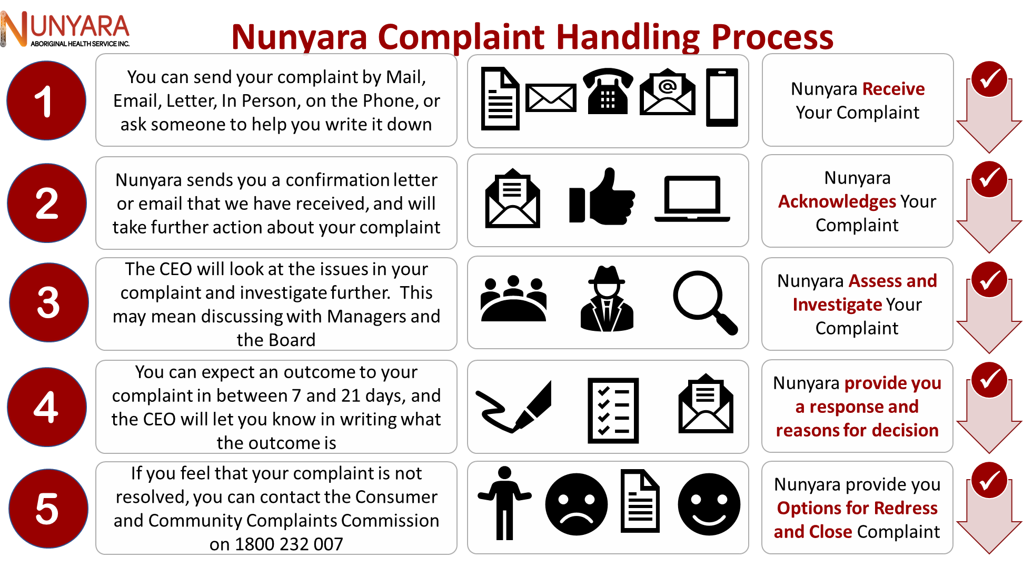

You may also contact the OAIC. Generally, the OAIC will require you to give them time to respond before they will investigate. For further information visit www.oaic.gov.au or call the OAIC on 1300 363 992.
Policy review statement
This document will be reviewed regularly to ensure it is in accordance with any changes that may occur. The updated document will be made available on our website and in our clinic waiting room.

